### 

**HOME OF THE BRAVES**

**Indian Hills Weekly Bulletin**

**October 29th through November 2nd**

|  |  |  |  |  |
| --- | --- | --- | --- | --- |
| **Monday**  **Oct. 29** | **Tuesday**  **Oct. 30** | **Wednesday**  **Oct. 31** | **Thursday**  **Nov. 1** | **Friday**  **Nov. 2** |
| **B Day** | **A Day** | **B Day**  **Happy Halloween!** | **A Day** | **B Day** |

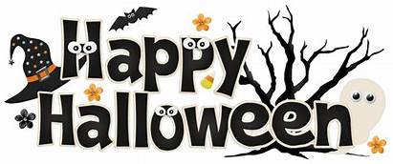

Get your Halloween Costumes ready! **Next Wednesday, October 31st** TNT will be sponsoring the Indian Hills annual costume contest. If interested, please stop by the hallway near the art gallery during homeroom to get your picture taken.

**As always please make sure all Halloween costumes follow dress code. Costumes must be appropriate, not offensive nor revealing. No hats, mask and fake weapons permitted.**



**Monday-Pajama Day**

**Tuesday-Jersey Day**

**Wednesday-Halloween**

**Thursday-Decades Day**

**Friday-Braves Day (Blue & Gold)**

**Indian Hills College Information for Juniors.**

Thursday, November 1st 6:00 p.m.

**Flow Follies Annual Musical Comedy Sign-ups & Auditions**

Join the Fun in Fundraising.

Open to all ages.

Sign-ups are: Saturday, October 25th 7-9 p.m.

November 13, 14, and 15th 7-9p.m Indian Hills High School.